Tag: a branch points to a snapshot in the history of your project

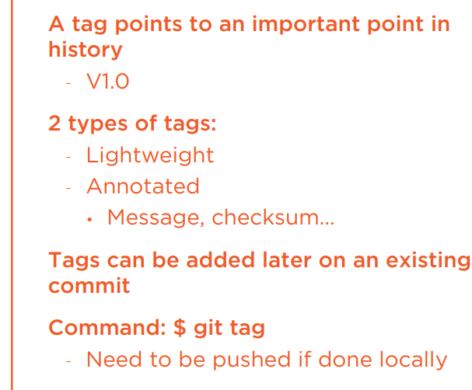

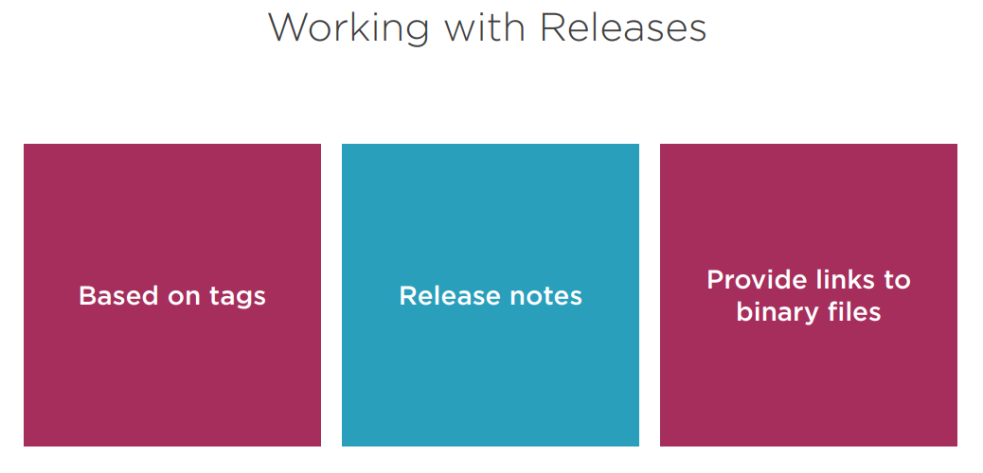



Realease have note, download uploaded source, source code

Ex: $ git ls –la

# view log

$ git log

$ git log –-oneline –-graph –-decorate –-all

# view tags

$ git tag

# create tag

$ git tag v0.1 master

or

$ git tag -a v0.1 -m “0.1 release” 025cd0d

# delete tag (remote or local)

git push --delete origin tagname

or

$ git tag -d tagname

$ git push origin :tagname

# push tag

$ git push –-tags